# **Caremark.com - Troubleshoot Member Log In Website**

|  |
| --- |
| **Registered Member Having Difficulty Logging Into Caremark.com** |

Verify that the member is typing the correct username. Access Caremark.com, and go to the Profile page (regardless of registration status shown from Compass) to confirm registration and verify member is using the correct username.

You may provide the member with their username as long as the member has been fully authenticated per the Web Support HIPAA guidelines. Refer to [Caremark.com – HIPAA Regulations and PHI Form](https://thesource.cvshealth.com/nuxeo/thesource/#!/view?docid=29c145e4-abda-481c-a24e-f3fd72145dbb).

1. Advise the member to click the **Forgot your password** link.

(The following screens will show for the members only. You will not be able to see these screens in compass.)

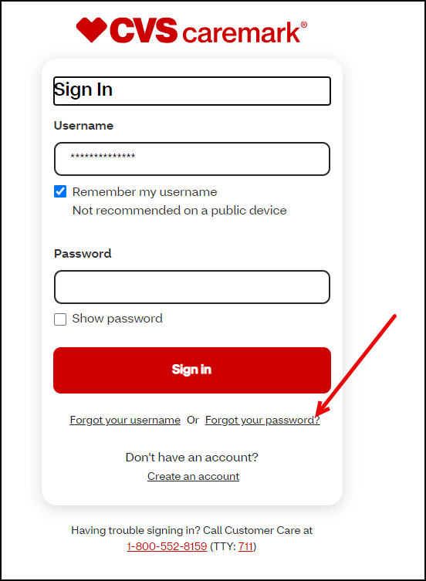

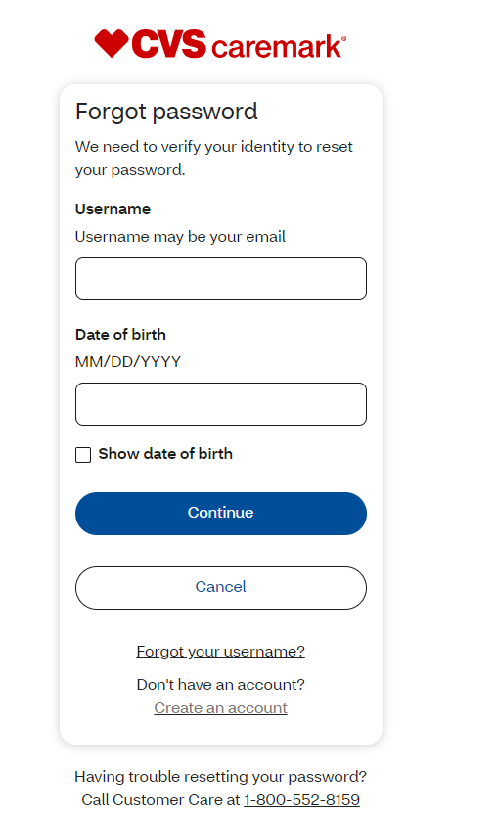

If the member is still having issues with logging on:

1. Remind the member that passwords are case sensitive.
2. Ask the member to confirm the CAPS Lock is not turned on and the number lock key is turned on.
3. Advise the member that no special characters can be used when creating a password.
4. If the member has their PC or device set to save usernames and/or passwords, the member may need to delete the username and password that pre-populates, and manually type in their username and password to log in.
5. Recommend that the member clear their browser cache before trying to log on. Refer to [Clearing your Cache](https://thesource.cvshealth.com/nuxeo/thesource/#!/view?docid=cd7acfcb-ad36-4da3-b973-faf08afb7dea).
6. If every effort has been made to assist the member with logging into their Caremark.com account without success.
7. The registration may need to be deleted. Refer to [Caremark.com Deleting Member Registration](https://thesource.cvshealth.com/nuxeo/thesource/#!/view?docid=1bdc5b7d-4fc6-4bab-8265-72ebcd074030). **Note:** You may also refer to [Caremark.com – Access Denied/Error 15 (External-Members Only)](https://thesource.cvshealth.com/nuxeo/thesource/#!/view?docid=43764aa8-01a2-4201-8ab4-c6ea3ebc7c81). Confirm the member is trying to sign in on Caremark.com (not CVS.com, CVSHealth App, or CVSSpecialty.com).
8. Check the client CIF to confirm client is not SSO only.

|  |
| --- |
| **Delay In Receiving Email or Text Alert with MFA Verification Code** |

In some instances, there may be a delay with receiving the verification code before it expires within 30 minutes after it is requested depending on volume of alerts being sent.

Workaround for Customer Care to assist members and provide the member with the code:

*  You **CANNOT** utilize this workaround **unless** the member has been fully authenticated with 4 authentication elements per the HIPAA Authentication Grid. If assisting another individual on the member’s behalf, you **MUST** speak to the member/beneficiary themselves (unless Power of Attorney (POA) OR Appointment of Representative (AOR) is in effect or member verbally authorizes at the time of the call to speak with someone else). Refer to the HIPAA Authentication Grid.
* View the last email or text alert sent within the last 30 minutes by navigating to the Compass Quick Access panel, select Communications, then select Digital Communications and provide the member with the code to enter and login with.

|  |
| --- |
| **Participant Lock Out** |

In some cases, members are locked out due to Confidential Communications received by the client or a HIPAA/Privacy related issue. Review the comments in Compass before unlocking a member’s Caremark.com account. You may see “You cannot access Caremark.com at this time”.

**Note:** The **Customer Service Access Control Tool** is available to Customer Care/Internal Users only. Members will be temporarily locked out of Caremark.com for 30 minutes after 3 unsuccessful/failed log in attempts for security reasons.

To unlock the member’s Caremark.com account,

1. Access the **Update My Profile** page.
2. Scroll down to the **Customer Service Access Control** section.
3. Remove the check box next to “**Lock the participant out**”.
4. Click “**Update Lockout**”.
5. Contact Senior Team for assistance if you do not have access to update or unlock the participant lockout.

|  |
| --- |
| **Related Documents** |

[Caremark.com - Common Member Assistance Call Types Index](https://thesource.cvshealth.com/nuxeo/thesource/#!/view?docid=947b0b38-401d-4b18-a08e-60348558a9b9)

**Full Details Document:**  [Caremark.com – Web Error Reporting and Troubleshooting Guide](https://thesource.cvshealth.com/nuxeo/thesource/#!/view?docid=8f4576f4-b866-4b64-beb0-c1089b3c32e8)

Not To Be Reproduced Or Disclosed to Others Without Prior Written Approval

**ELECTRONIC DATA = OFFICIAL VERSION / PAPER COPY = INFORMATIONAL ONLY**